**DESIGN SPECIFICATION REPORT**

|  |  |  |
| --- | --- | --- |
| **Course** | |  | | --- | | BLG-411E Software Engineering | |
| **CRN** | 13330 |
| **Year/Semester** | 2017-2018 Fall |
| **Project Name** | Transportation Management Optimization |
| **Team Members** | Student Number Student Name  150160537 Okan YILDIRIM  150160531 Fatih YILMAZ  150160530 Özgür AKTAŞ  150160546 Hasan Emre ARI  941515004 Ali UÇAR |
| **Submission Date** | 28/11/2017 |

1. **INTRODUCTION**

Design specification document is a visual description of the software project named Transportation Management Optimization. This document has great importance and effective steps for reach successful result. This design document provides so many advantages to have good communication between the different roles of the project and early preventions against misunderstandings and miscommunication for all stakeholders.

* 1. **Goal**

This design document includes the relationships between database, desktop and website applications of the software project named Transportation Management Optimization. The user interface examples and software model are also given in this document to allow the customer to review the project. Other purpose is of the design specification is to be used as a reference for developers. The goal of this document is to provide more information to stakeholders of the project, is aimed to prevent the confusions.

* 1. **Contents and Organization**

**1.2.1 Data Model**

The process of creating a data model in software engineering is important for project flow. In this part, for starters, the Data Model of this project is introduced in this design document. The Data model was explained with the use of the Entity Relationship (ER) diagrams in which shows details and relationships between database tables. In next step, these important data considerations have been showed. With the Data Flow Diagrams, the operating paths of the project have been presented.

**1.2.2 Software Model**

The software model part of this design document has four parts. The first part is System Architecture which includes the structure of the project. The Component Diagram part presents the inputs, outputs and the relationships between components. For each component, Class diagram is created and explained in detail. In final part, the Sequence/Communication diagrams are drawn for all user stories written before in Requirements Specification document.

**1.2.3 User Interface Model**

Designs can be better presented to customers through drafts made with different techniques. Mockups are used for this purpose. The important screen mock-ups for website and desktop applications are given in the last part of this document. Each mock-up is considered as an example for a user interfaces of the components.

1. **DATA MODEL**
   1. **General Data Model**

* The Entity relation diagram is as shown below.
* User entity has attributes such as id, full name, address, email, username, authority, user type.
* The User type represents different users, such as admin, distributor and company official.
* For example, the admin or company official can handle the shipping and shipping detail sections. Distributor can give order.
* Shipping detail includes a map for delivery. There are ways to use this map. In order to create the road, two pool points are needed.
* Also inside of shipping detail, contain order entity. The Order entity holds the id of the distributor that issued it and its id, date, and status variables.
* In the order detail, it keeps from what kind of product and what order in which these products are located.
* Product holds the id and name values of the products.

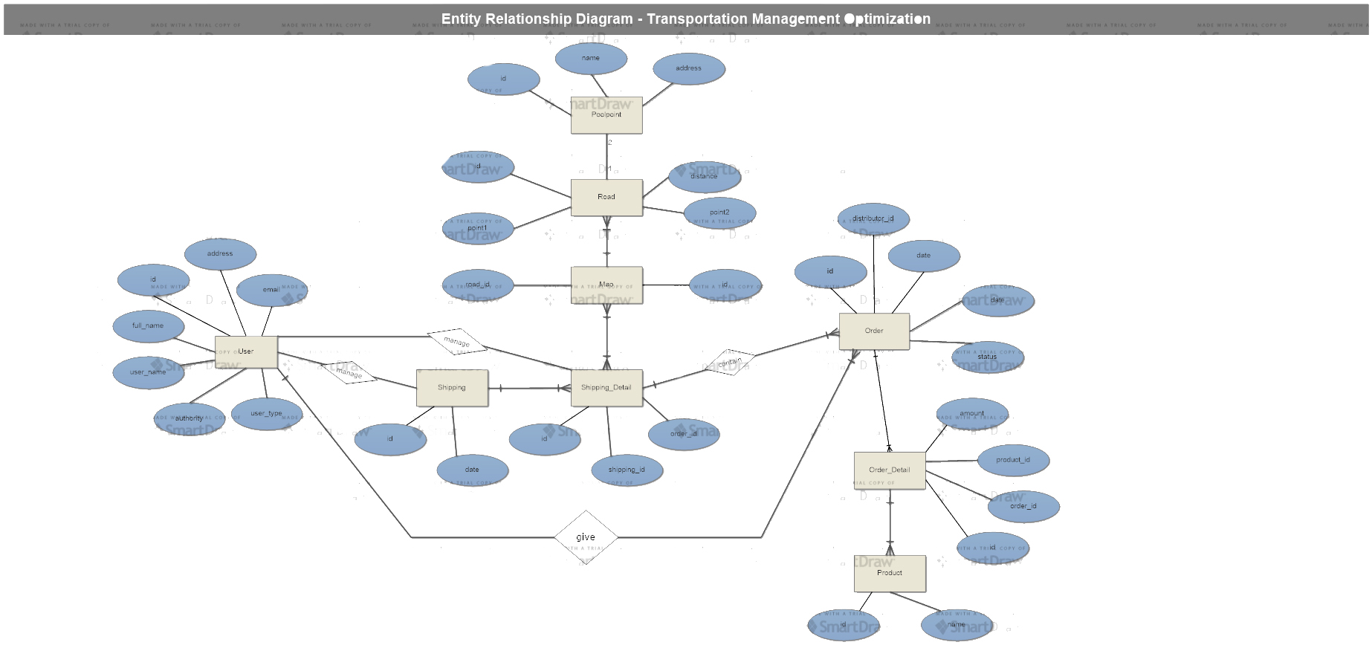

* 1. **Important Data Considerations**

Our application has two end point which is shown to the distributers on the web and company officials on the desktop. Both endpoints accesses the database remotely. As a database we use MYSQL and to transfer data we use JSON format. For our application we have User, Order, Product, Map etc. tables which are given on the ER diagrams in detailed. All ids are automatically created and values are assigned sequentially. Moreover, we put some constraints in terms of size, type etc. There are also triggers such as whenever user gives order, data about orders added automatically to Order Detail table.

For example User tables data transfer object is given below:

|  |  |  |  |
| --- | --- | --- | --- |
| { |  |  |  |
|  | “id”: 321546,  “full_name”: “Fatih YILMAZ”,  “username”: “fthylmz”,  “password”: “***”,  “address”: “Maslak, Sarıyer”,  “email”: “[yilmazfa16@itu.edu.tr](mailto:yilmazfa16@itu.edu.tr)”  “type”: 0 | | |
|  |
|  |
|  |
|  |
|  |  | … | |
| } |  |  |  |

* 1. **Data Flow**

Data flow diagrams are given below from level 0 to 3.

* + 1. **Data Flow Diagram Level 0**

For Data Flow Diagram Level 0,

* Simply there are three component of the general system: Users, applications and database.
* User access database through applications and applications has both input and output for both users and database.

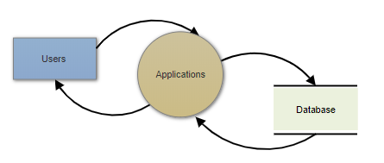

**2.3.2 Data Flow Diagram Level 1**

On the Data Flow Diagrams Level 1,

* Users types and applications are enhanced
* Admin and Company Official access database through Desktop Application
* Distributor access database through Web Applications
* Both Desk Application and Web Applications has relation and communication with database.
* Users gives input and takes output from the applications
* Applications gives and takes output from the database

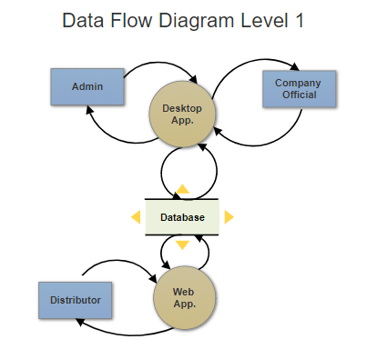

**2.3.3 Data Flow Diagram Level 2**

For Data Flow Diagram Level 0,

* Desktop App. is enhanced to four services: User Manager, Login, Order Manager and Transportation Optimization Manager.
* Admin and Company Official can use Login, Order Manager and Transportation Optimization Manager services as users. Admin has an extra authority to use User Manager. User gives input ant takes output from the services.
* WEB app. is enhanced to four services Login, User Account Manager, Order Manager and Order History Manager.
* Distributor can use Login, User Account Manager, Order Manager and Order History Manager services.
* Database enhanced to its tables as seen below.
* Each services can access specified tables and can do add, delete and update operations. These services give input and takes output from the database.

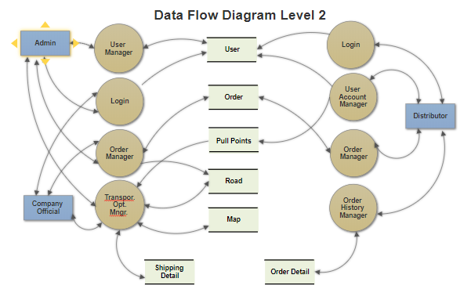

1. **SOFTWARE MODEL**
   1. **System Architecture**

* In our system, we have three types of user as admin, company official and distributor.
* There are two applications and a database on the system.
* Desktop Application has four services: Login, Order Manager and Transportation Optimization. Admin and company official can use these services on applications.
* Admin has an extra authority to manage other users through User Manager service.
* Web Application has four services: services Login, User Account Manager, Order Manager and Order History Manager.Distributor can use these services on applications.
* Each application has relations and communications with database.
* Services in the applications, access specified tables in the database.
* Database is managed according to the Database rules.

C:\Users\okkaa\Desktop\desig\system.tif

* 1. **Component (Package) Diagram**

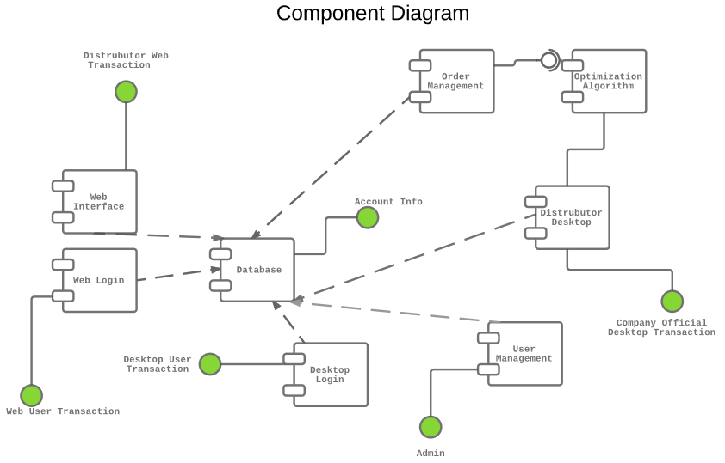

* Web interface, Web login, Database Desktop Login, User Management Order Management, Optimization Algorithm, Distributor Desktop, Desktop Login are our components.
* Web interface waits input from Distributor Web Transaction.
* Web login waits input from Web User Transaction
* Desktop Login waits input from Desktop User Transaction
* User Management waits input from Admin
* Distributor waits input from Company Official Desktop Transaction
* Optimization Algorithm takes from Order Management component
* Database waits input from account info
* All outputs from the components return to Database.
  1. **Class Diagrams**

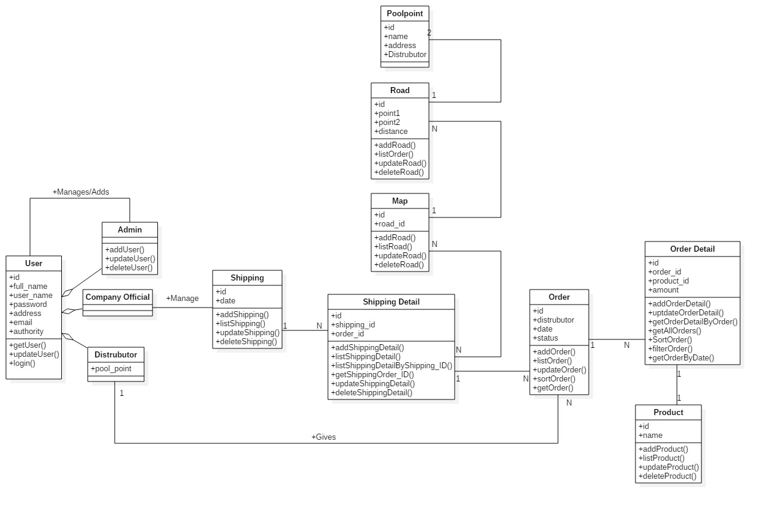

* 1. **Sequence/Communication Diagrams**

1. **USER INTERFACE MODEL**
   1. **WEB App. GUI**
      1. **Login**

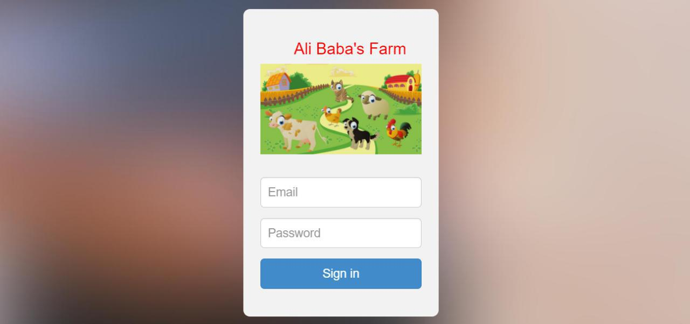

* + 1. **Menu**

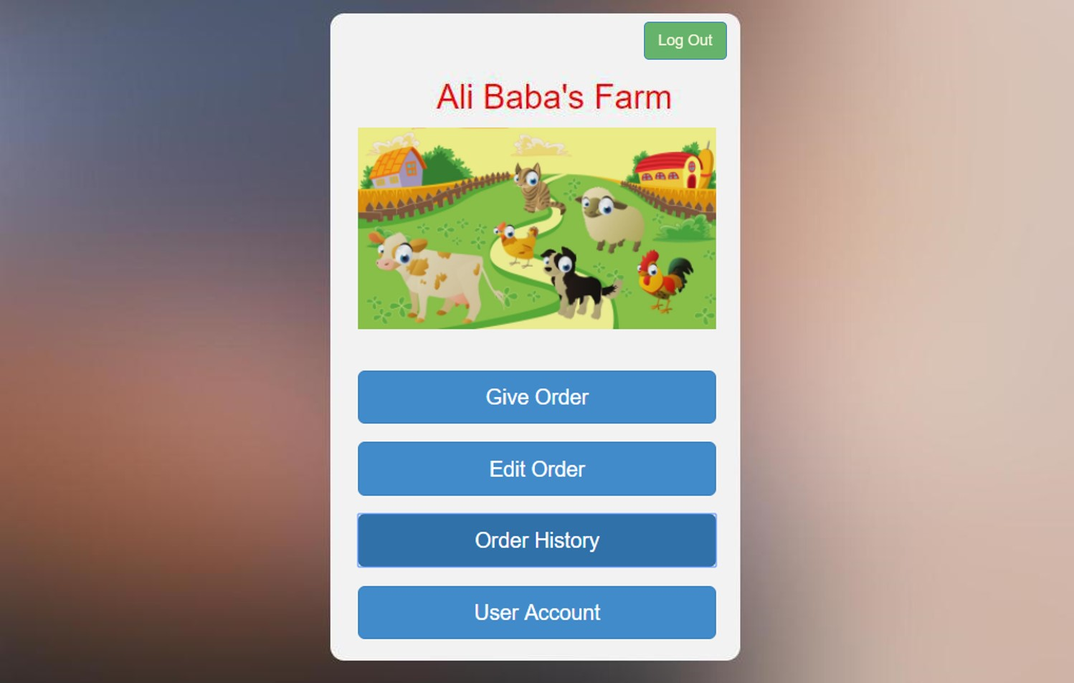

* + 1. **Give Order**

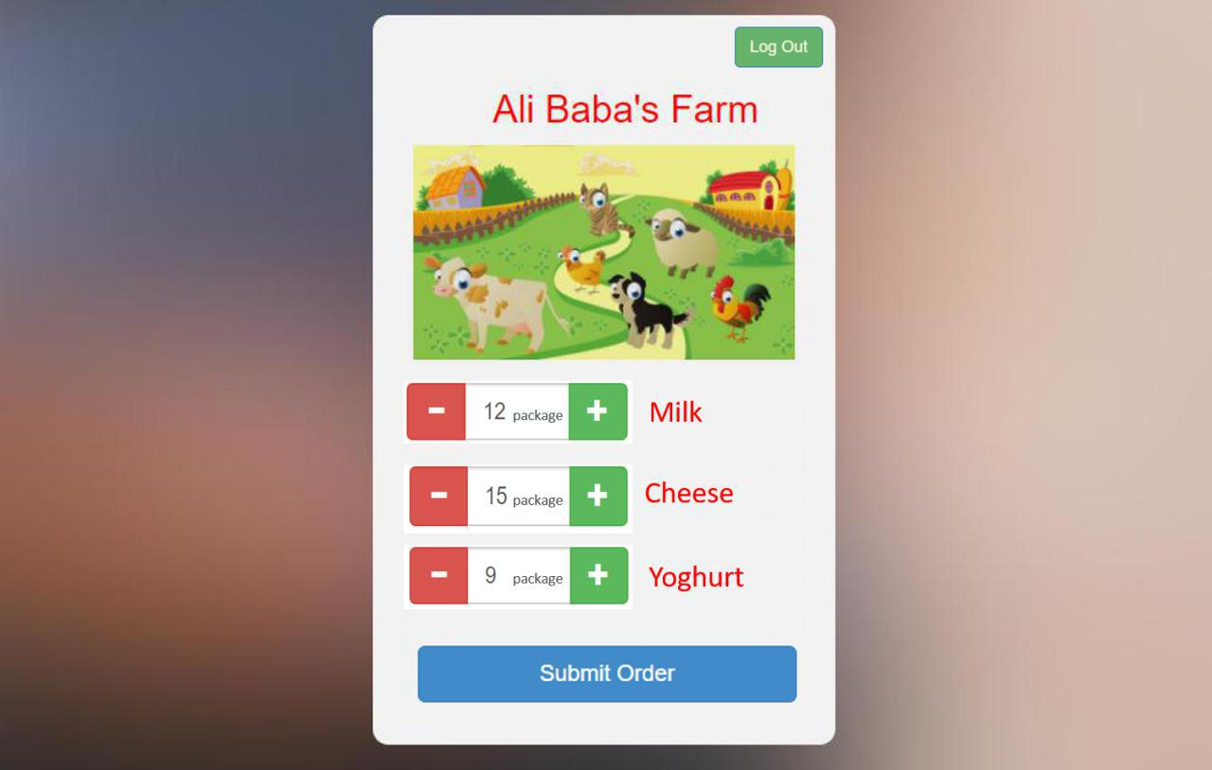

* + 1. **Order History**

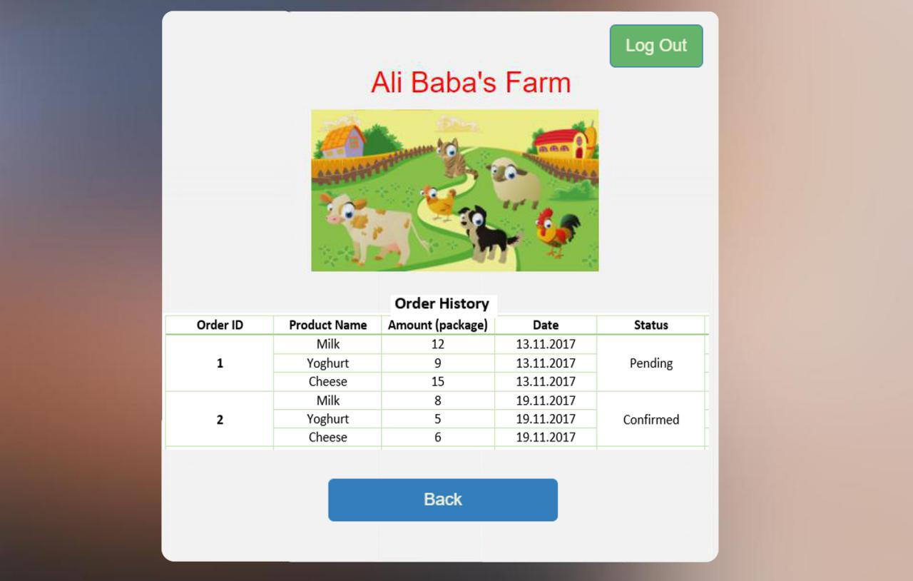

* + 1. **Edit Order**

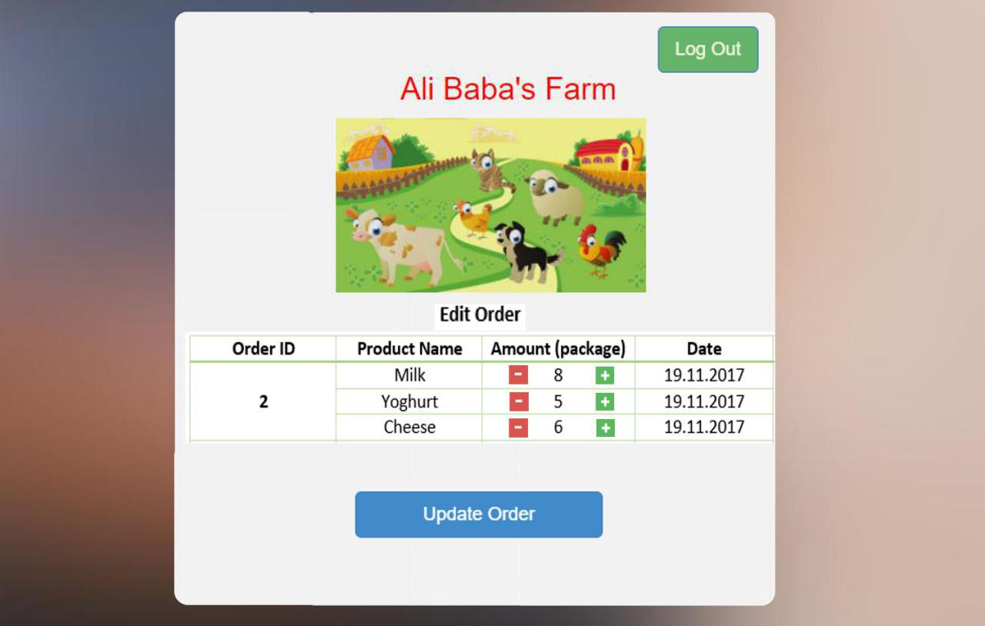

* 1. **Desktop App GUI**
     1. **Login**

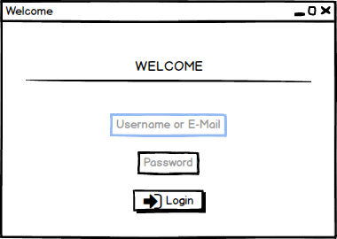

**4.2.2 Manager Orders**

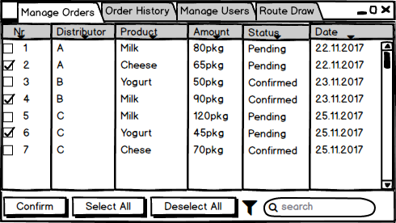

**4.2.3 Order History**

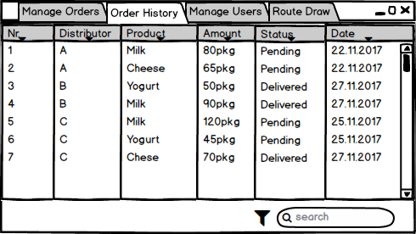

**4.2.2 Manage Users**

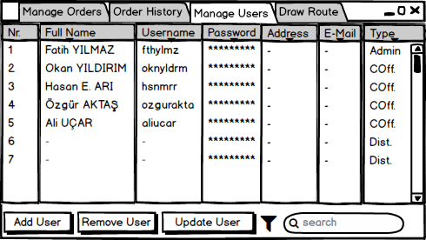

**4.2.2 Draw Route**

